Your Ref: 2010/226
Enquiries: Allan Macdonald (08) 9216 3952)

Hon Catherine Branson QC
President
Australian Human Rights Commission
GPO Box 5218
SYDNEY NSW 2001

Dear Ms Branson

DISCRIMINATION ON THE BASIS OF SEXUAL ORIENTATION AND/OR GENDER IDENTITY

Thank you for your letter dated 6 October 2010, inviting me to make a submission to the Commission in relation to its consultation into federal protection from discrimination on the basis of sexual orientation and sex and/or gender identity.

I support the introduction of federal legislation that prohibits discrimination on the ground of sexual orientation and gender identity. Aside from the Fair Work Act 2009, the Commonwealth is the only Australian jurisdiction not to have expressly legislated to make discrimination on the ground of a person’s sexual orientation unlawful. As your discussion paper points out, although there is no international declaration or treaty specifically recognising the rights of gay and lesbian people, or people who identify as being of a sex other than that which they have at birth, Australia has committed to the principles set out in Articles 2 and 26 of the International Covenant on Civil and Political Rights. Legal protection from discrimination on the grounds of sexual orientation and gender identity would advance those principles.

As you will be aware, it is unlawful under the WA Equal Opportunity Act 1984 (“the Act”) to discriminate against a person on the ground of his or her sexual orientation, in all of the areas covered by the Act, including employment, education, accommodation, and the provision of goods and services. The Act was amended in 2002 to include the new ground, following extensive consultation and the release of the Ministerial Committee’s report, ‘Lesbian and Gay Law Reform’, in June 2001.

It is also unlawful under the Act to discriminate against a person on gender history grounds. This ground was incorporated in 2000. Gender history refers to a person who has undergone a gender reassignment procedure, and been granted a recognition certificate under the Gender Reassignment Act 2000.

In 2002, the then Acting Commissioner for Equal Opportunity, Moira Rayner, conducted a consultation into discrimination on the ground of gender identity in Western Australia, that is, discrimination against people who identify as being of a sex other than their sex at birth, but who have not undergone a gender reassignment procedure and obtained a recognition certificate. A report recommending that the Act should be amended to include such a ground, modelled on the equivalent ground under the Victorian Equal Opportunity Act 1995, was provided to the then Attorney General in December 2002. In May 2007, the Commission released its report on the review of the Equal Opportunity Act. The report referred to the earlier recommendation regarding gender identity, and re-affirmed that the Act should be amended accordingly. However, this has not occurred. In the absence of any equivalent Western Australian law, I would support Commonwealth legislation that makes discrimination on the ground of a person’s gender identity unlawful.

Definition

‘Sexual orientation’ is defined in the Act as meaning heterosexuality, homosexuality, lesbianism or bisexuality, both actual and imputed. The Report originally recommended that the definition not include ‘heterosexuality’, as is the case with the definition in the NSW Anti-Discrimination Act 1977. The Government rejected this recommendation, and included heterosexuality in the definition in the amending legislation. All the States and Territories include ‘heterosexuality’ in their respective definitions, apart from NSW. Whether or not in theory this is the best approach, in practice the great majority of complaints of sexual orientation discrimination lodged with the Equal Opportunity Commission since 2002 have been from gay, lesbian, or bisexual people. My view is that excluding ‘heterosexuality’ from the definition is of little practical effect, and should be included in any Commonwealth definition.

The Report also recommended that the term ‘lesbianism’ should be included in the definition, as the term ‘homosexuality’ has acquired, through common usage, an association with male sexual preference. The Committee was concerned that the fight for recognition and equality by the gay and lesbian community may mask ongoing gender inequality that exists within it.

Importantly, a person who is discriminated against on the ground of being a relative or associate of a person with a particular sexual orientation is also protected by the Act. Commonwealth legislation should also extend to relatives and associates.

Legislative Scheme

The ground of sexual orientation operates in the same way as the other grounds under the Act. The tests for direct and indirect discrimination, the areas of public life to which the ground would apply, and the general exceptions, are the same across all grounds. With perhaps the exception of the Racial Discrimination Act, existing discrimination legislation in the States and Territories, and in the Commonwealth, operates in a similar way, applying the same tests, in the same areas of public life. The differences between the jurisdictions are not as great as the similarities.

The Report in 2001 recommended that the new ground of sexual orientation should fit into the existing scheme of the Act. I agree with that approach. If significant reform is made in the way discrimination legislation in a particular jurisdiction is to operate, then it should apply universally, and not just to the most recent ground to be incorporated. I am aware that the Federal Government is considering preparing draft legislation combining the different Commonwealth discrimination laws, as part of its Human Rights Framework announced this year. This is to be commended. If the Commonwealth is to legislate to make discrimination on the grounds of sexual orientation and gender identity unlawful, then it should be part of the combined Act, capturing any reforms or advancements in the application of discrimination law at Commonwealth level generally.

Exceptions

A number of exceptions apply to the ground of sexual orientation discrimination under the Act. However, all of them are the standard exceptions that apply to all grounds, either in specific areas, or generally:

- domestic duties in private households;
- accommodation for no more than 3 persons in the same place that the person who is providing the accommodation resides;
- accommodation provided by a religious body
- disposal of interest in land by will or gift;
- order of a court or the State Administrative Tribunal;
- conferring of charitable benefits
- admission of persons as members of a voluntary body, and the provision of benefits to those members;
- ordination, training, and appointment of priests and ministers of religion;
- employment by educational institutions established for religious purposes
- establishments providing accommodation for aged persons
- measures intended to achieve equality

Exceptions like these are included in discrimination legislation in the other States and Territories. Whilst the existing exceptions may serve as a guide in the drafting of a Commonwealth law, they should not be adopted without question. In the report of the review of the Equal Opportunity Act in 2007, it was recommended that the exception that permits religious educational institutions to discriminate against employees and contract workers (on any ground under the Act) be restricted to those workers with teaching or pastoral responsibilities. The sexual orientation of a person employed in administration, or as a gardener, should not be regarded as relevant for the purposes avoiding injury to the religious susceptibilities of an educational institution’s students and staff.
Likewise, I question the appropriateness of the exception relating to accommodation provided by religious bodies, particularly as many religious organisations today have arrangements with governments and other non-profit organisations to provide low cost public housing. As part of the Human Rights Framework, a rare opportunity exists for the Federal Government to re-evaluate the historical exceptions and determine which ones are really necessary, not only in respect to sexual orientation and gender identity discrimination, but in a new combined Commonwealth discrimination law.

Thank you again for inviting me to make a submission.

Yours sincerely

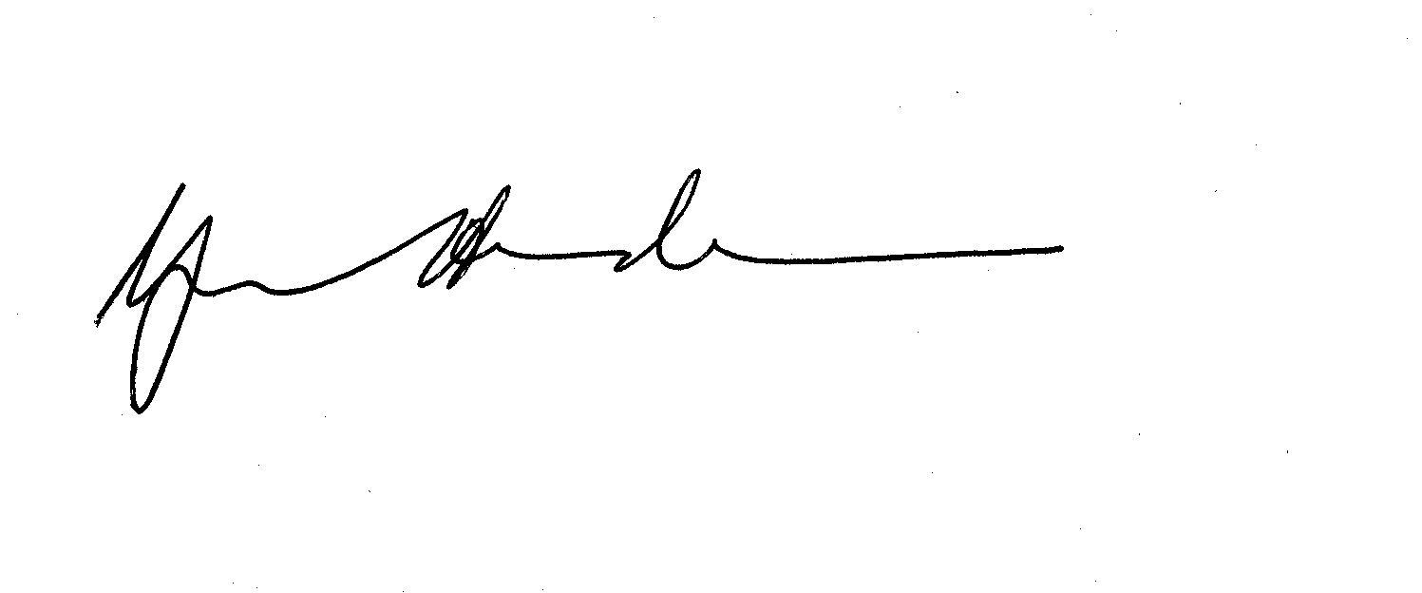

Yvonne Henderson
COMMISSIONER FOR EQUAL OPPORTUNITY

1 December 2010

